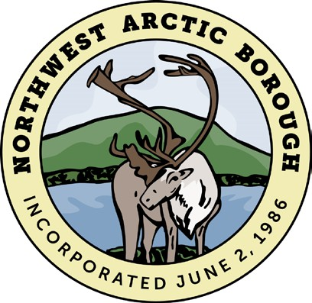Northwest Arctic Borough

***2024 SUBSISTENCE FISHING GRANT APPLICATION***

*The Northwest Arctic Borough Subsistence Fishing Grant was created to support residents take part in subsistence fishing. This grant is intended to encourage active engagement in this family activity which provides a commodity beneficial to the health and well-being of the community as a whole.*

**Application period opens June 12, 2024 at 8 am and ends June 16 2024 at 4:30 pm. Awards are granted on a first come, first served basis. Applications will only be accepted during the application period. Early applications must be resubmitted during the application period. Late applications will not be accepted.**

# RULES

* This grant is limited to one application per household.
* Only one award per household every three years.
* Applicants must be 18 years of age or older.
* Incomplete applications will not be accepted. **\*SEE REQUIREMENTS\***
* The award is a subsistence net, white fish, or salmon.
* The resale of any subsistence equipment obtained by this grant is **absolutely prohibited**. This includes “squares” or raffles.

# REQUIREMENTS

▢ Proof of current Northwest Arctic Borough residency is required. A copy of a utility bill, State ID, or Voter Registration are acceptable.

▢ A complete application, submitted within the application period, in one of the acceptable methods below.

# I acknowledge and agree to the rules and requirements of this grant:

***Signature Date***

Name Birth Date:

E-mail: Phone #: Address: City: State: Zip:

# Email completed applications and attachments to: [hsheldon@nwabor.org,](mailto:aerlich@nwabor.org) return to the Borough office at 163 Lagoon Street Kotzebue, or fax to NWAB (907) 442-2930.

Ambler Ivisaappaat, Buckland Nunatchiaq, Deering Ipnatchiaq, Kiana Katyaak, Kivalina Kivaliñiq, Kobuk Laugviik, Kotzebue Qikiqtaġruk, Noatak Nautaaq, Noorvik Nuurvik, Selawik Akuliġaq, Shungnak Isiŋnaq